**EXPERIMENT 4 Date: 3rd February 2023**

**TITLE:** **DDL (Data Definition Language) commands with Data Constraints**

**Objective:** To understand the concept of data constraints that is enforced on data being stored in the table. Focus on Primary Key, Foreign Key and constraints.

1. **Create table AUTHOR = {Author_ID, Lastname, Firstname, Email, City, Country}**

**Constraints:**

* **Author_ID – text data type, 5 characters, primary key**
* **Lastname – text data type, 15 characters, not null**
* **Firstname – text data type, 15 characters, not null**
* **Email – text data type, 40 characters,**
* **City – text data type, 15 characters,**
* **Country – text data type, 15 characters**

**Query:**

CREATE TABLE AUTHOR (

AUTHOR_ID VARCHAR(5) PRIMARY KEY,

LASTNAME VARCHAR(15),

FIRSTNAME VARCHAR(15),

EMAIL VARCHAR(40),

CITY VARCHAR(15),

COUNTRY VARCHAR(15)

);

DESC AUTHOR;

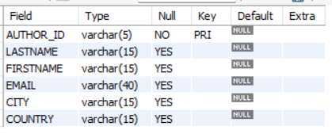

1. **Create Table BOOK = {Book_ID, Book_Title, Copies}**

**Constraints:**

* **Book_ID – text data type, 5 characters Primary Key Start With Character B**
* **Book_Title - Text data Type Not Null**
* **Copies- No.of copies Data Type int always greater the 2**

**Query:**

CREATE TABLE BOOK (

BOOK_ID VARCHAR(5) PRIMARY KEY CHECK(BOOK_ID LIKE "B%"),

BOOK_TITLE VARCHAR(50),

COPIES INT CHECK(COPIES>2)

);

DESC BOOK;

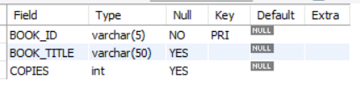

1. **Create table AUTHOR_LIST = {Author_ID , Book_ID , Role}**

**Constraints:**

* **Author_ID – text data type, 5 characters, referenced by Author_ID from AUTHOR table**
* **Book_ID – text data type, 5 characters, referenced by Book_ID from BOOK table**
* **Role – text data type, 15 characters**
* **and primary key is: Author_ID, Book_ID**

**Query:**

CREATE TABLE AUTHOR_LIST (

AUTHOR_ID VARCHAR(5),

BOOK_ID VARCHAR(5),

ROLE VARCHAR(15),

PRIMARY KEY (AUTHOR_ID, BOOK_ID),

FOREIGN KEY (AUTHOR_ID) REFERENCES AUTHOR(AUTHOR_ID),

FOREIGN KEY (BOOK_ID) REFERENCES BOOK(BOOK_ID)

);

DESC AUTHOR_LIST;

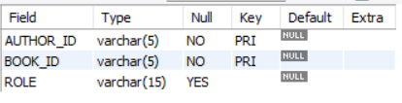

1. **Add four records in each tables AUTHOR, BOOK, BOOK_LIST.**
2. **AUTHOR Table**

INSERT INTO AUTHOR VALUES("A0001", "Tripathi", "Amish", "amish.tripathi@gmail.com", "London", "United Kingdom");

INSERT INTO AUTHOR VALUES("A0002", "Christie", "Agatha", "agatha.christie@gmail.com", "London", "United Kingdom");

INSERT INTO AUTHOR VALUES("A0003", "Doyle", "Arthur Cona", "ac.doyle@gmail.com", "London", "United Kingdom");

INSERT INTO AUTHOR VALUES("A0004", "Verne", "Jules", "jules.verne@gmail.com", "Paris", "France");

SELECT * FROM AUTHOR;

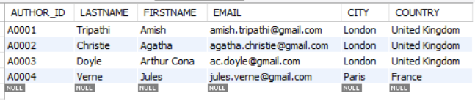

1. **BOOK Table**

INSERT INTO BOOK VALUES("B0001", "War of Lanka", 200);

INSERT INTO BOOK VALUES("B0002", "The Immortals of Meluha", 500);

INSERT INTO BOOK VALUES("B0003", "Murder on the Orient Express", 300);

INSERT INTO BOOK VALUES("B0004", "The Adventues of Sherlock Holmes", 400);

SELECT * FROM BOOK;

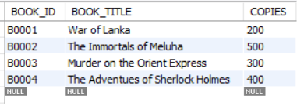

1. **AUTHOR_LIST Table**

INSERT INTO AUTHOR_LIST VALUES("A0001", "B0001", "Writer");

INSERT INTO AUTHOR_LIST VALUES("A0001", "B0002", "Author");

INSERT INTO AUTHOR_LIST VALUES("A0002", "B0003", "Author");

INSERT INTO AUTHOR_LIST VALUES("A0003", "B0004", "Author");

SELECT * FROM AUTHOR_LIST;

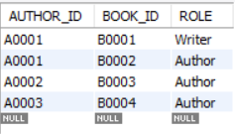

1. **Alter structure of table AUTHOR_LIST add the field Publisher data type of 30 Character.**

ALTER TABLE AUTHOR_LIST ADD PUBLISHER VARCHAR(30);

